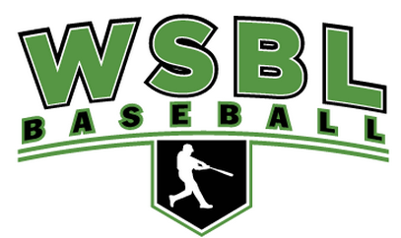

Stock Uniform Package - $95

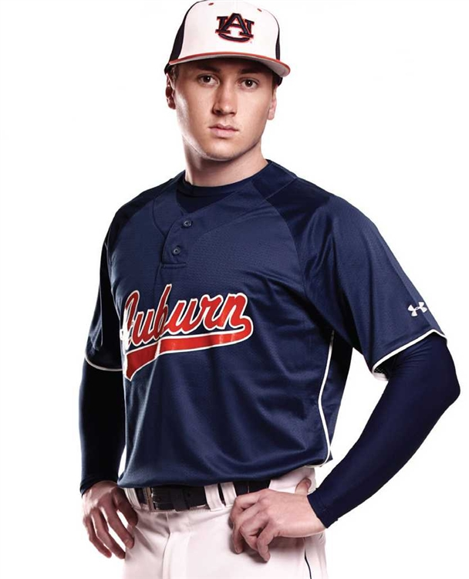 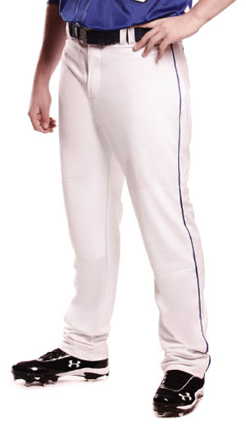

Pricing Includes:

* Classic Henley Jersey - front print & back number (one or two-color)
* UA Cap with front embroidery.
* Stock Rundown pant with or without pipe.
* All-Sport Tube Sock
* Baseball Belt
* Coaches Apparel for free (ask for details)

Custom online shops are available for parents and players to order added t-shirts, hoods, footwear, batting gloves, etc at the WSBL discount.